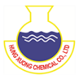 **SAFETY DATA SHEET HUNTEX TV-001**

**Substance classified as hazardous and hazardous pictograms**

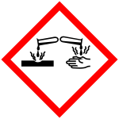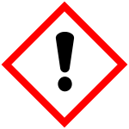

Corrosive –Harmful

**Prevention and practices**

* Avoid release to the environment.
* Do not eat, drink or smoke when working. Wash hands before and after work.
* 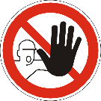Use appropriate protective equipment when working with chemicals.
* Do not inhale gases/ vapours/ aerosols. Avoid contact with eyes and skin.
* Wash contaminated clothing and other protective equipment before storage or re-use.

**Measures to handle in case of emergency**

**On fire:**

* + - 1. Fire fighting with water water spray, foam, dry powder, CO2.
      2. In the event of fire the following can be released: Carbon monoxide (CO), Carbon dioxide (CO2).
      3.  Fire fighter should wear self-contained breathing apparatus and suitable protective clothing if risk of exposure to vapor or product of combustion.

**Leak or break:**

1. Avoid contacting, touching, or walking over spilled material.
2. Take up and fill into a closable container.
3. Prevent run off into drains and waterways.
4. Take up liquid spill into absorbent material, eg: soil, sand and other non-flammable absorbent material.

**First aid measures**

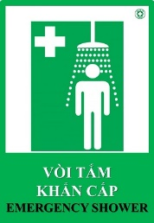 **Inhalation:** Remove the victim from exposure or move to well- ventilated area.

**Skin contact:** Wash with plenty of soap and water. Remove contaminated clothing, shoes and leather accessories.

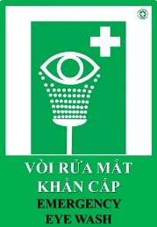 **Eye contact:** Rinse cautiously with water for several minutes. Remove contact lenses, if present and easy to do. Continue rinsing.

**Ingestion:** Rinse mouth with water, drink plenty of water.

**If feel unwell, seek medical advice.**

**Storage**

Keep container tightly closed and store in a cool, temperature 15-25°c, dry well- ventilated location.

Store away from heat,flames, ignition sources and incompatibles.

Avoid contact with alkalis, oxidizing agents. Check regularly for leaks..

**Waste treatment**

Waste from residue: Disposal should be in accordance with local regulations and legislation. Contaminated packaging: Dispose of empty contaminated containers in accordance with regulations and legislation.